Aim: - Configuration of Switch and Router using CLI commands in Cisco Packet Tracer.

Router : Routers are the multiport devices and more sophisticated as compared to repeaters and bridges. It contains a routing table that enables it to make decision about the route i.e. to determine which of several possible paths between the source and destination is the best for a particular transmission. A router is a device that connects two or more packet-switched networks or subnetworks. It serves two primary functions: managing traffic between these networks by forwarding data packets to their intended IP addresses, and allowing multiple devices to use the same Internet connection. There are several types of routers, but most routers pass data between LANs (local area networks) and WANs (wide area networks). A LAN is a group of connected devices restricted to a specific geographic area. A LAN usually requires a single router. A WAN, by contrast, is a large network spread out over a vast geographic area. Large organizations and companies that operate in multiple locations across the country, for instance, will need separate LANs for each location, which then connect to the other LANs to form a WAN. Because a WAN is distributed over a large area, it often necessitates multiple routers and switches\*.

Software Required: - Cisco Packet Tracer

Outputs: -

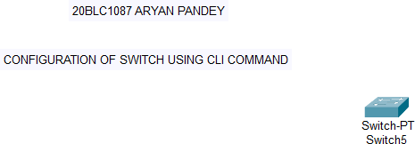

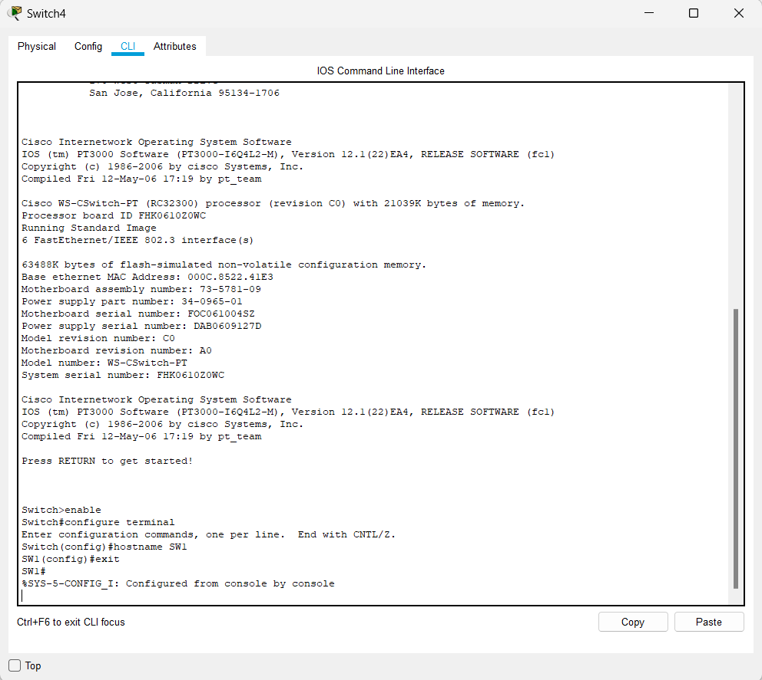

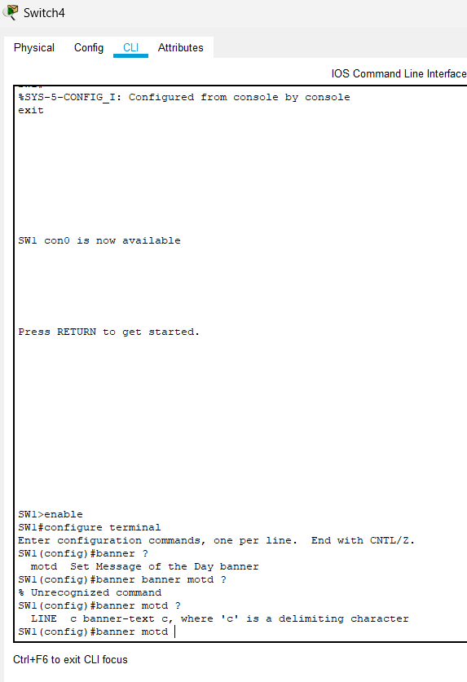

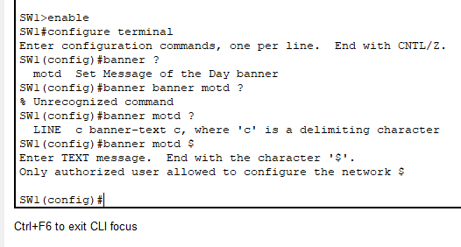

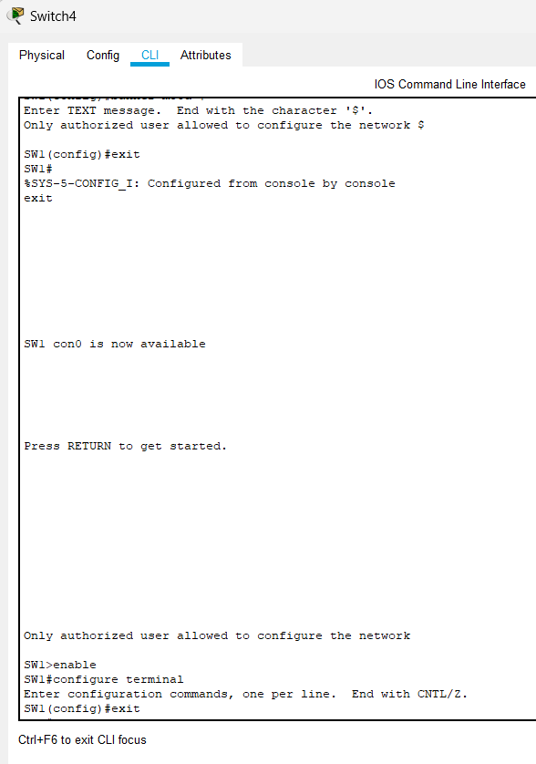

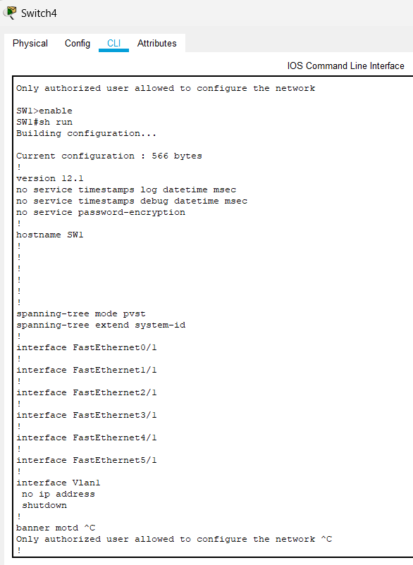

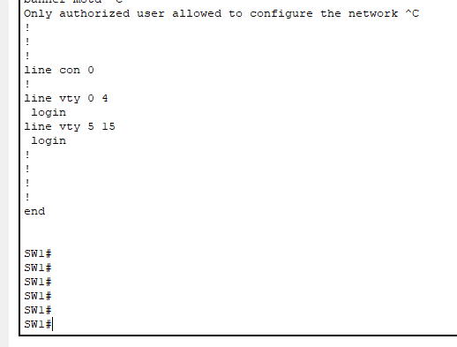

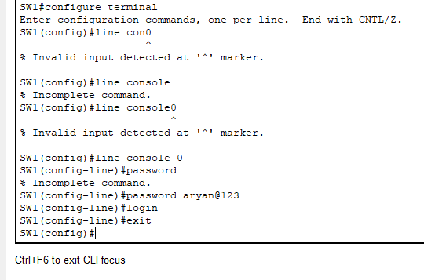

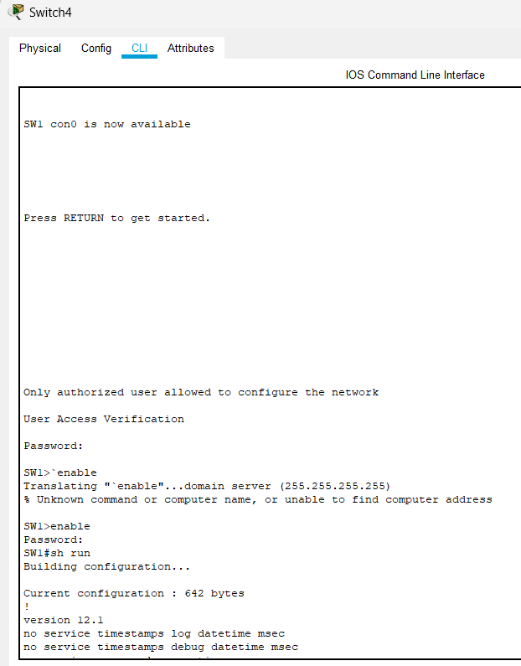

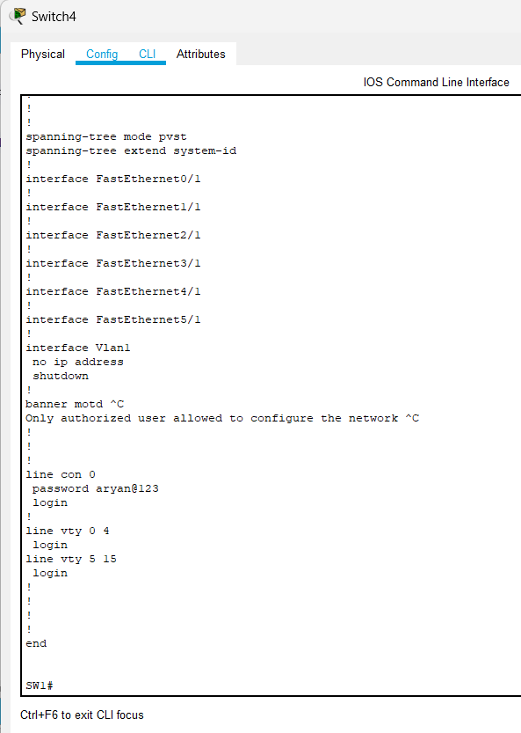

ROUTER: -

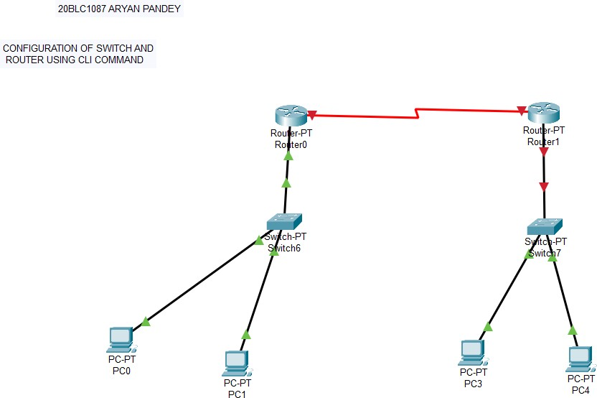

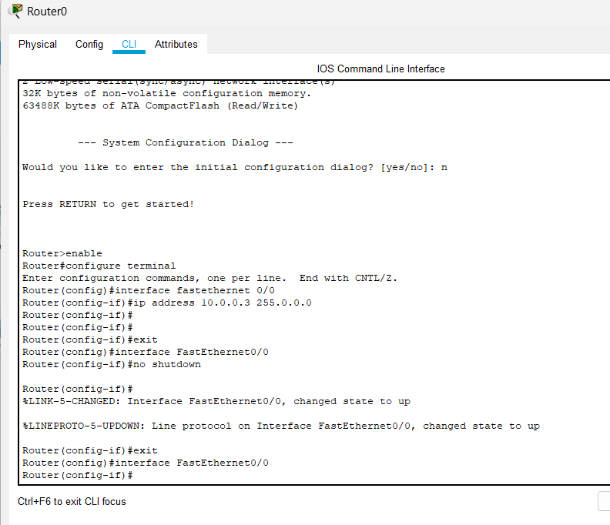

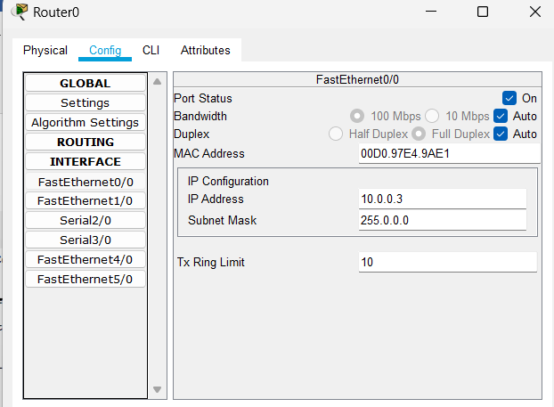

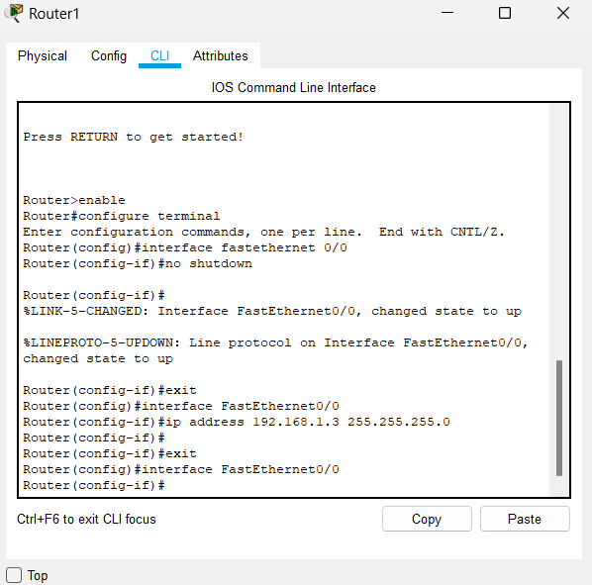

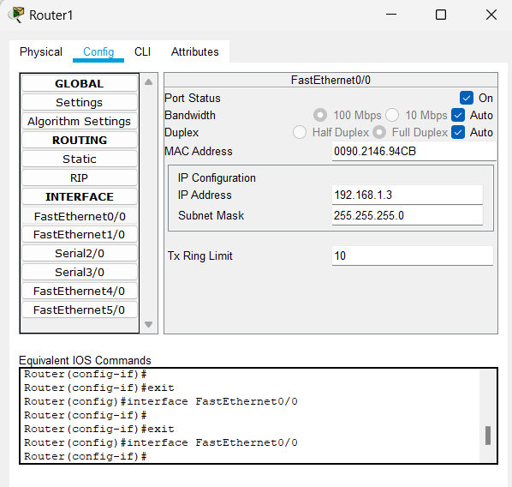

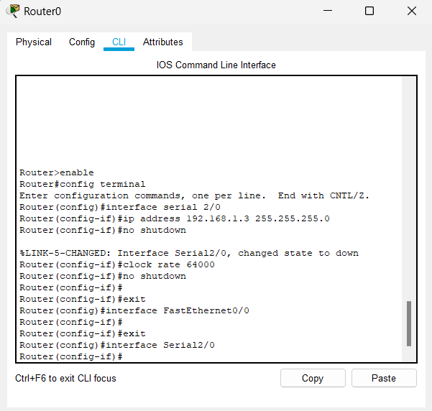

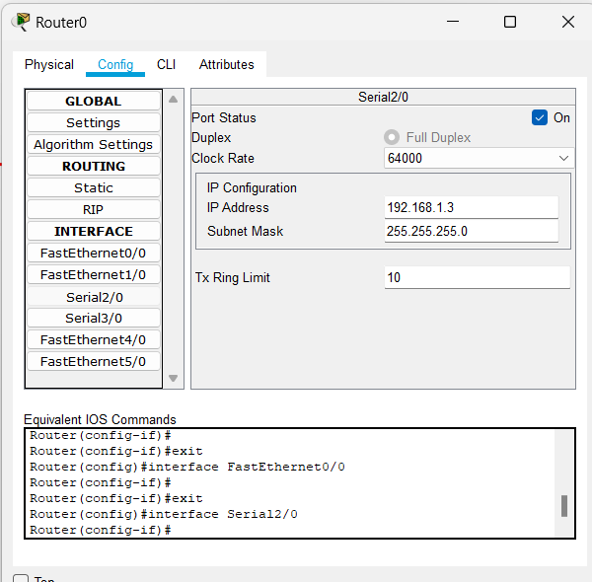

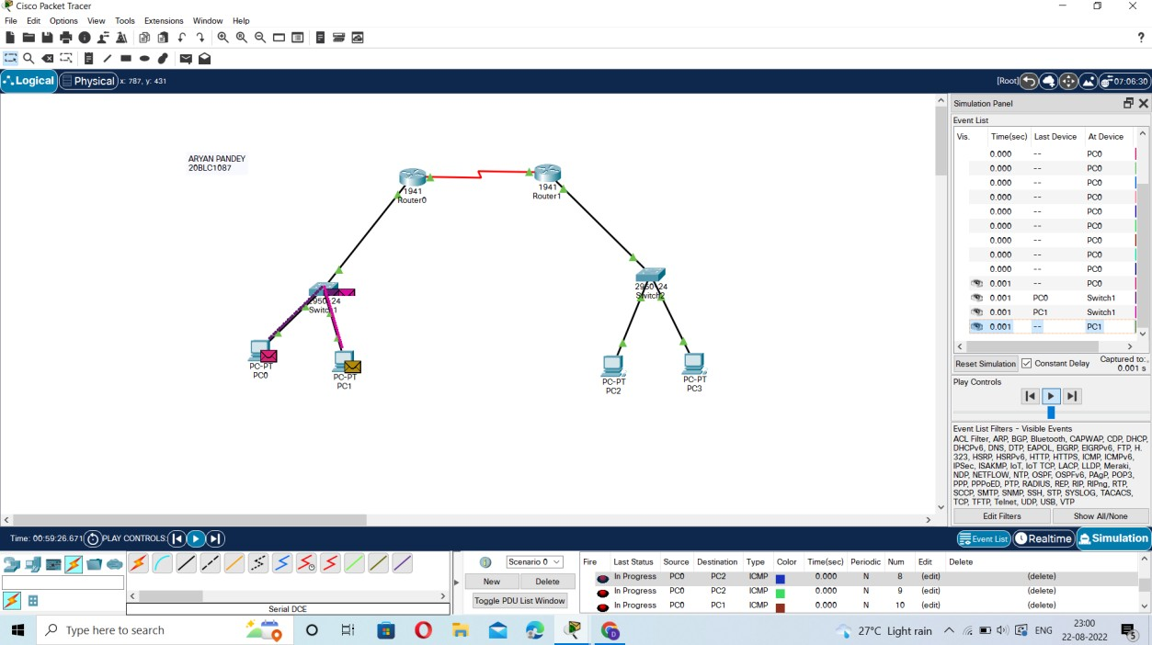

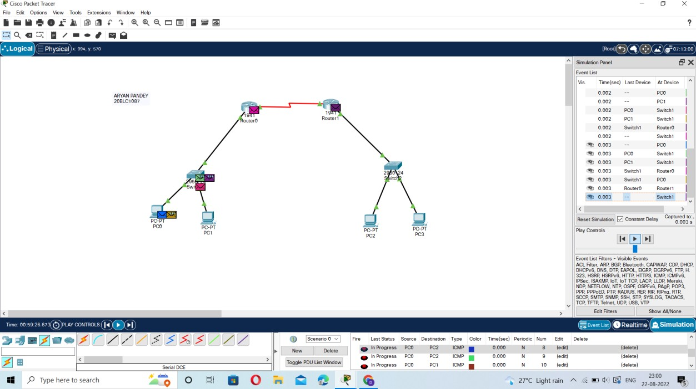

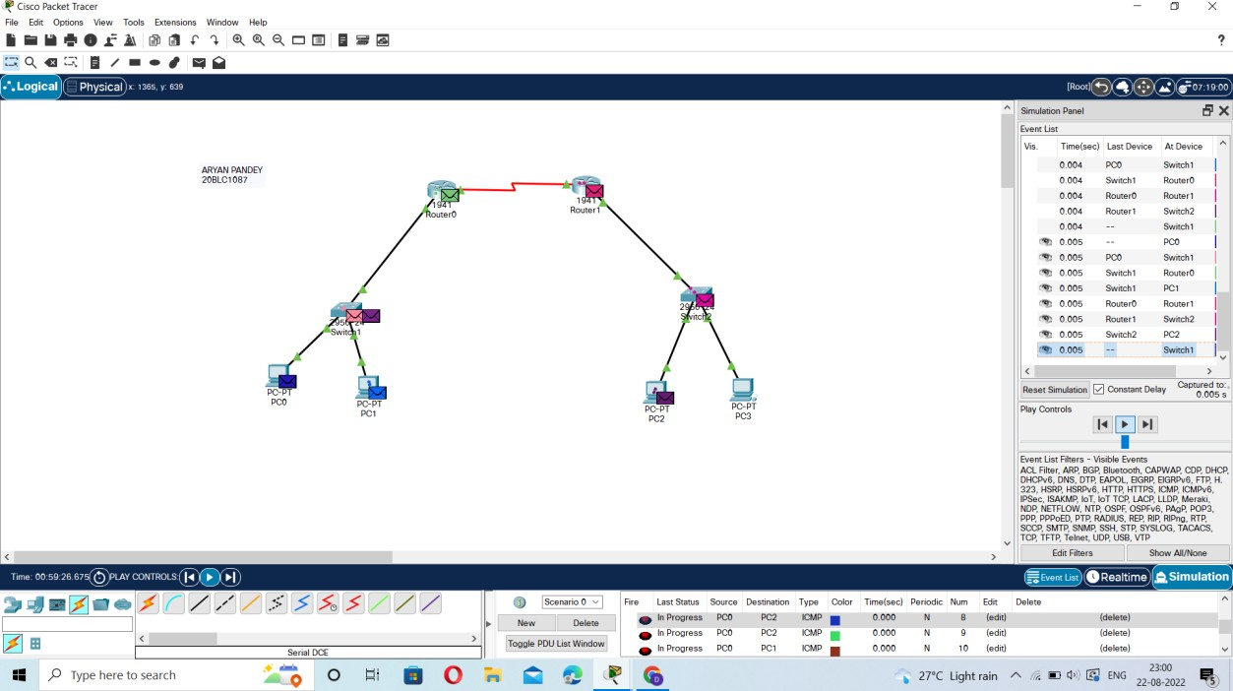

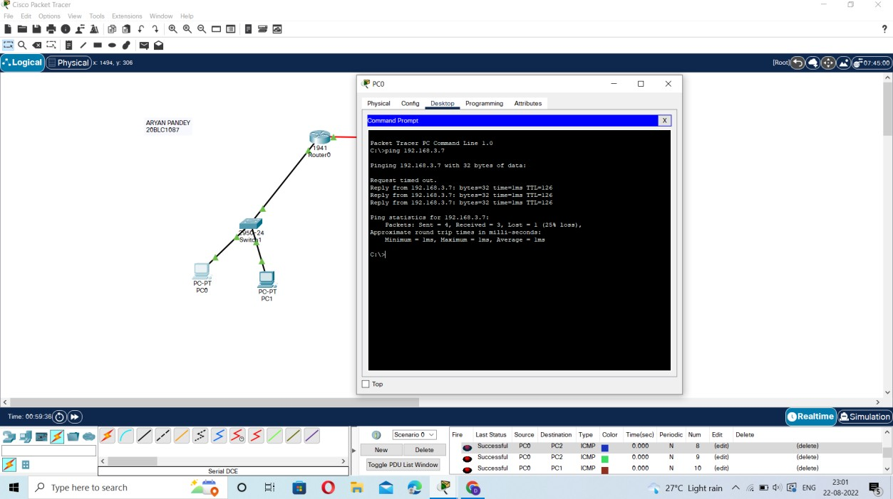

Verification Status: -

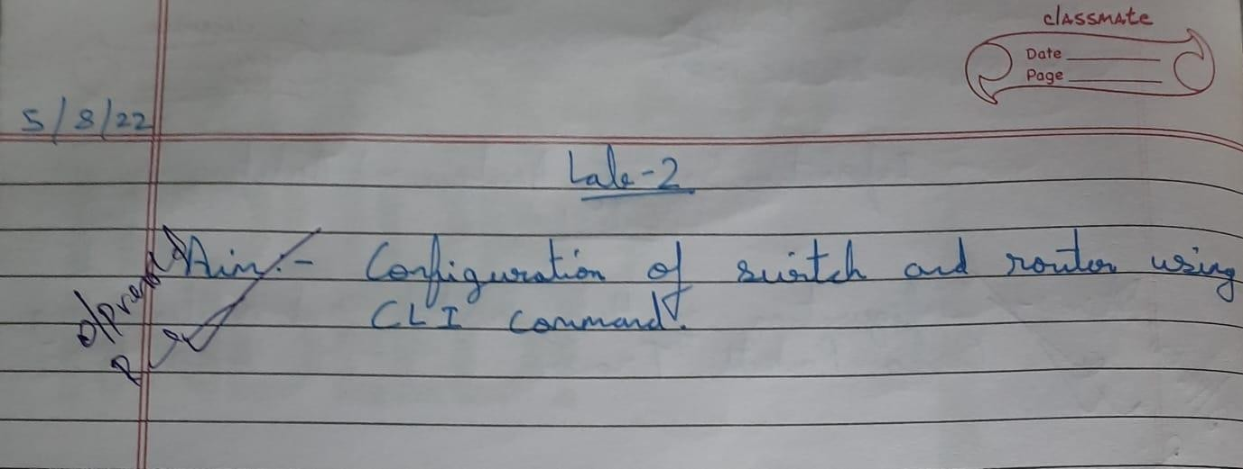

Result: -

Configuration of Switch and Router using CLI command Cisco Packet Tracer was successful and all the given task were completed.